Telepathology GitHub Cheat Sheet

# Overview

It is a contractual requirement to place all work products in <https://github.com/VHAINNOVATIONS/Telepathology>

The repository is organized into subfolders

* Documents
* Source
* Test

In order to interact with GitHub one needs a client, or use the command line interfaces. To download a GUI go to <http://git-scm.com/> and download the GUI client for your OS. If you are using an IDE (.net, Java, etc.) it may have built in support for Git.

The Windows client is available at:

<https://github-windows.s3.amazonaws.com/GitHubSetup.exe>

Once you have installed the client environment, clone the online repository to your system

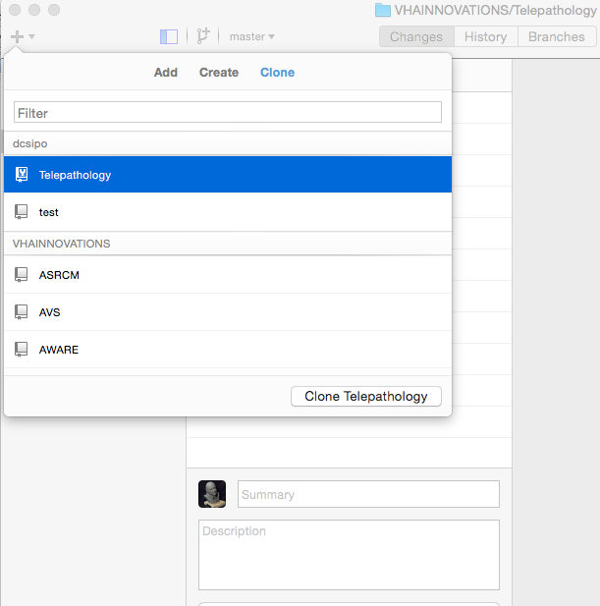

select the directory where you want to clone the repository

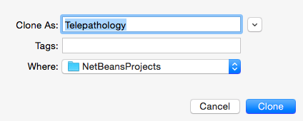

Cloning the project will create a directory on your system that contains all the subfolders defined for the project in the online repository

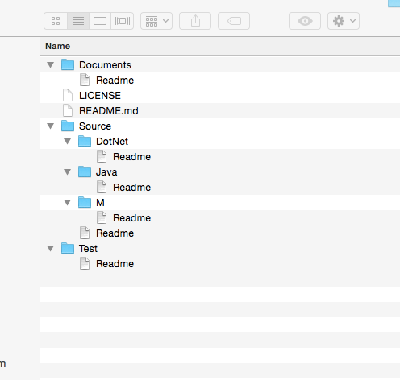

In order to place objects into the repository or change them simply move them into the appropriate folder in your local copy of the repository and commit the changes

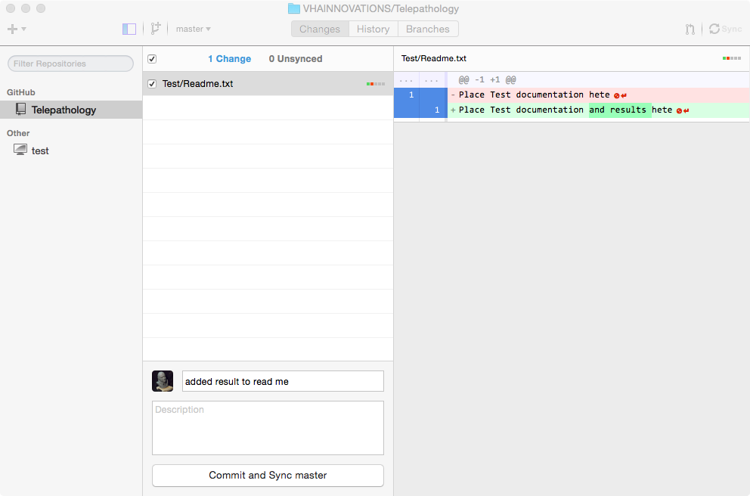

once you committed the changes and synced the master the changes are uploaded to GitHub.